**Software Requirements Specification**

For

**FASHION OUTFIT RECOMMENDATION SYSTEM**

| **Specialization** | **SAP ID** | **Name** |
| --- | --- | --- |
| B.Tech CSE AIML | 500075359 | Niharika Agrawal |
| B.Tech CSE AIML | 500076519 | Prabhraj Singh |
| B.Tech CSE AIML | 500075307 | Pradumn Nathawat |



Department of Informatics

School Of Computer Science

UNIVERSITY OF PETROLEUM & ENERGY STUDIES,

DEHRADUN- 248007. Uttarakhand

**Table of Contents**

| **Topic** | | **Page No** |
| --- | --- | --- |
| Table of Content | |  |
| Revision History | |  |
| 1 | Introduction |  |
|  | 1.1 Purpose of the Project |  |
|  | 1.2 Target Beneficiary |  |
|  | 1.3 Project Scope |  |
|  | 1.4 References |  |
| 2 | Project Description |  |
|  | 2.1 Reference Algorithm |  |
|  | 2.2 Data/ Data structure |  |
|  | 2.3 SWOT Analysis |  |
|  | 2.4 Project Features |  |
|  | 2.5 User Classes and Characteristics |  |
|  | 2.6 Design and Implementation Constraints |  |
|  | 2.7 Design diagrams |  |
|  | 2.8 Assumption and Dependencies |  |
| 3 | System Requirements |  |
|  | 3.1 User Interface |  |
|  | 3.2 Software Interface |  |
|  | 3.3 Database Interface |  |
|  | 3.4 Protocols |  |
| 4 | Non-functional Requirements |  |
|  | 4.1 Performance requirements |  |
|  | 4.2 Security requirements |  |
|  | 4.3 Software Quality Attributes |  |
| 5 | Other Requirements |  |
| Appendix A: Glossary | |  |
| Appendix B: Analysis Model | |  |
| Appendix C: Issues List | |  |

**Revision History**

| **Date** | **Change** | **Reason for Changes** | **Mentor Signature** |
| --- | --- | --- | --- |
|  |  |  |  |
|  |  |  |  |
|  |  |  |  |
|  |  |  |  |

1. **INTRODUCTION**

1.1 Purpose of The Project

Clothing is the most important thing that people should consider every day. People want to look good, as we can see that there are lot of online social sites such as instagram, facebook, etc., where people can show their fashion pictures to the world. also people like to buy lot of clothes to try different styles to make them look more appealed, which is reflected in the growing online clothing sales, reaching 370 billion dollars in the US.

Recent years have seen more and more researchers use computer vision to study fashion. The main focus is to parse clothing from photographs, which is widely used on online shopping sites.

In addition, it will make people’s lives more convenient if there is a system which can suggest good outfit to users based on the clothing that the users already have.

An occasion-oriented clothing recommendation is given to suggest the most suitable clothing from the user’s own clothing photo album which just put attent to the occasion not the outfit itself.

1.2 Target Beneficiary

Deciding what clothes to wear for an event can often be a time-consuming task. At times, it is important to find clothes that are well-suited for an event. What we wear could have a good or a bad impression on people. Not wearing appropriate clothes on certain occasions can at times offend some people. For example, at a Christian funeral, wearing black conservative clothes is customary while at a Hindu funeral, wearing white conservative clothes is the norm. At Buddhist funerals, wearing the color red is frowned upon. Hence, the problem of event-based clothing needs to be addressed. These days, most of the people share photos of the events they attend on social media platforms.

1.3 Project Scope

This project aims at generating captions for images using neural language models. There has been a substantial increase in the number of proposed models for images specific tasks since neural language models and convolutional neural networks(CNN) became popular. Our project has its base on one of such works, which uses a variant of object detection coupled with a CNN. We need to first identify the type of event using object detection. Once we found out about the event in the image/s, we will identify the clothes worn at that event. After this, we will start finding correlation between the event and clothes worn. Then we will ultimately find the most frequently used clothes and recommend similar clothes using a nearest neighbor approach.

1.4 References & GitHub link

<https://scholarworks.sjsu.edu/cgi/viewcontent.cgi?article=1611&context=etd_projects>

<https://staff.fnwi.uva.nl/m.derijke/wp-content/papercite-data/pdf/lin-2019-improving.pdf>

<https://www.atlantis-press.com/proceedings/iccia-17/25880175>

<https://github.com/xthan/polyvore-dataset>

<https://towardsdatascience.com/building-a-personalized-real-time-fashion-collection-recommender-22dc90c150cb>

<https://blog.dataiku.com/outfit-recommendation-system>

<https://github.com/prabhrajsingh/Major-Project>

1. **PROJECT DESCRIPTION**

2.1 Reference Model

CNN is crucial in working with images. It takes as input an image, assigns importance (weights and biases) to various aspects/objects in the image, and differentiates one from the other. The CNN makes use of filters(also known as Kernels) which help in feature learning(detect abstract concepts, like Blurring, Edge Detection, Sharpening, etc), much the same as a human brain identifying objects in time and space.

2.2 Libraries

* **tensorflow:**

TensorFlow is an end-to-end open source platform for machine learning. It has a comprehensive, flexible ecosystem of tools, libraries and community resources that lets researchers push the state-of-the-art in ML and developers easily build and deploy ML powered applications.

* **keras:**

Keras is an API designed for human beings, not machines. Keras follows best practices for reducing cognitive load: it offers consistent & simple APIs, it minimizes the number of user actions required for common use cases, and it provides clear & actionable error messages.

* **numpy:**

NumPy is a general-purpose array-processing package. It provides a high-performance multidimensional array object and tools for working with these arrays. It is the fundamental package for scientific computing with Python. It contains various features.

* **matplotlib:**

Matplotlib is an amazing visualization library in Python for 2D plots of arrays. Matplotlib is a multi-platform data visualization library built on NumPy arrays and designed to work with the broader SciPy stack. One of the greatest benefits of visualization is that it allows us visual access to huge amounts of data in easily digestible visuals. Matplotlib consists of several plots like line, bar, scatter, histogram, etc.

* **OpenCV:**

OpenCV is an image processing package for Python language. It incorporates lightweight image processing tools that aid in editing, creating, and saving images. It supports a large number of image file formats including BMP, PNG, JPEG, and TIFF. The library encourages adding support for newer formats in the library by creating new file decoders.

2.3 Characteristics of Data

We used a novel dataset from a clothing-oriented online website Polyvore.com. In this website, user can create an outfit from a pool of items by himself/herself and post the outfit to share with others. Each shared outfit includes information such as outfit name, items in the outfit, similar styles, comments about the outfit, number of how many people like the outfit and so on.

2.4 SWOT Analysis

Strength - We are using Polyvore dataset in which each shared outfit includes information such as outfit name, items in the outfit, similar styles, comments about the outfit, number of how many people like the outfit and so on.We don't have to do everything on our own, we use the pre-trained model that has been already trained on large datasets and extract the features from these models and use them for our tasks.

Weakness - The training of the deep network in our model is huge.In order to extract the feature of one image of item, firstly, we preprocess image to make the size of the item in the image consistent, then we resize the image

Opportunities - Deciding what clothes to wear for an event can often be a time-consuming task. At times, it is important to find clothes that are well-suited for an event. What we wear could have a good or a bad impression on people. Not wearing appropriate clothes on certain occasions can at times offend some people. Hence, the problem of event-based clothing needs to be addressed. These days, most of the people share photos of the events they attend on social media platforms.

Threats - The personal information collected by recommenders raises the risk of unwanted exposure of that information. Also, malicious users can bias or sabotage the recommendations that are provided to other users.

2.5 Project Features

* Our project’s main feature is to get an outfit that would be a good fit for the user.
* To get an outfit we will be using CNN model and applying transfer learning to enhance the workflow and reduce the training time by a huge margin
* we will be developing multiple outfits and from those outfits by ranking methods we will have the max rank outfit as a recommended outfit.
* the image provided by the model will be then displayed to the user as the end product.

2.6 User Classes and Characteristics

There are many extensions of this project, such as recommending articles of clothing to users to enhance their existing wardrobe or dressing store mannequins.

If nothing else, it can at least help you get dressed in the morning when it feels like you have nothing to wear.

2.7 Design and Implementation Constraints

* This is an unsupervised problem and fashion is pretty subjective, so it’s tough to really evaluate what a “good” or “bad” model looks like.
* the recommendation may sometime give an outfit that the user may not like.
* The model may overfit quickly because of the small data.

2.8 Design diagram

[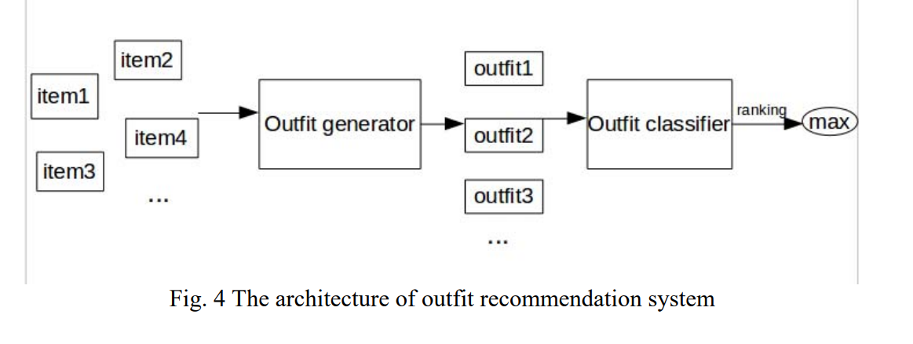](https://drive.google.com/file/d/1NaVU0voJOf-iw2AEJpj58AKJblPQhRla/view?usp=drive_open)

1. **SYSTEM REQUIREMENTS**

3.1 User Interface:

The user interface will be a web page created with the help of python django framework where we simply provide an image and will have the outfit presented to us.

3.2 Software Interface:

* OS: Windows 7 and above, Recommended: Windows 10.
* CPU: Intel processor with 64-bit support
* Disk Storage: 8GB of free disk space.
* internet connection

3.3 Dataset Interface

This dataset contains 21,889 outfits from polyvore.com, in which 17,316 are for training, 1,497 for validation and 3,076 for testing.

3.4 Protocols

* The project is done in the python programming language and needs to follow the rules and syntax of the python language.
* During the implementation of the CNN model, we have to extract the feature vector from the image but due to transfer learning inclusion, we need to make some changes and then integrate it with our model.

1. NON - FUNCTIONAL REQUIREMENTS

4.1 Performance requirements

With the use of the google colab notebook we will be taking the help of its GPU acceleration feature where a complex procedure can be performed drastically fast and with the google drive linked directly to the notebook we need not manually upload the dataset

1. CONCLUSION

the model will give a combination of clothes for the specific occasion

5.1 Output

